Draft Operations Plan for Leaburg Dam Trap: 2015

The purpose of this document is to describe proposed operation of the adult fish trap in the south bank ladder at Leaburg Dam in the McKenzie River in 2015. In recent years, the trap was used to remove hatchery-origin Chinook salmon as part of ODFW’s efforts to reduce the proportion of hatchery-origin spawners (pHOS) in the McKenzie River wild fish sanctuary in the river reaches above the dam. We propose to continue the practice but expand the operation to begin earlier and occur more often.

Passage of Chinook salmon at Leaburg Dam is generally characterized by upstream movement of predominantly natural-origin fish, mostly in June and July, with a secondary peak usually dominated by hatchery-origin (adipose-clipped) fish in September (Figure 1). Clearly, we do not want to operate the trap during the main peak (generally in May through early July) because the bulk of the fish moving at that time are naturally-produced; the potential for delaying migration or causing injury to wild fish is greater. However, focusing the trapping operation in August and September greatly reduces the number of wild fish that will be handled.

The goal of the trapping operation is to annually remove 100 or more adipose-clipped Chinook salmon that would otherwise spawn in the wild fish sanctuary above Leaburg Dam. We propose to begin operating the trap when we estimate that > 80 % of the wild run has passed. Historically (2009 – 2014), 80% of the wild run passed in the third or fourth week of July with 90% passing by the third or fourth week of August (Figure 2). It is conceivable that the run thresholds could occur earlier in 2015, given the hydrologic conditions and water temperatures to date, so we will use the existing continuous video monitoring of clipped and unclipped fish passing Leaburg Dam and be prepared to begin trapping as early as July 1. When the weekly total and weekly unclipped counts drop precipitously, the trap in the south bank ladder will begin operation. Note that, as shown in Figure 1, in 2013 and 2014 the unclipped count dropped but then rose again as a second pulse of unclipped fish moved upstream. In both cases the early drop in counts occurred in June. In all years, including 2013 and 2014, a drop in counts in the month of July was followed by low numbers of upstream migrants through August and a pulse of migrants in September when counts of clipped fish equaled or, usually, exceeded counts of unclipped fish.

The tentative schedule of operations is shown in Table 1. The schedule will be managed adaptively. If unclipped Chinook salmon abundance exceeds 50% of the total on any day, the trap will be pulled and passive monitoring of relative abundance of clipped and unclipped Chinook salmon will resume. The trapping operation will only be reinstated when absolute numbers of unclipped fish are low and the relative abundance of clipped fish equals or exceeds that of unclipped fish. The trap will operate every weekday and will be checked at least twice daily, once in the morning and once in the late afternoon. For the morning check, if adult fish are in the trap, then they will be sorted by hand with unclipped fish immediately passed upstream. Adipose clipped fish will be hoisted into an on-site transport tank and delivered to the McKenzie Hatchery to be used for broodstock or one of the other approved uses (outplanting, donation, or sale). The afternoon check will be a visual inspection to guard against the extremely unlikely event whereby substantial numbers of adult fish enter the trap during daylight hours. We intend for the trap to be left open on weekends but are exploring the possibility of finding staff and funds to support operation of the trap on weekends.

The trap counts and timing upon which Figures 1 and 2 are based represent total counts through both the left bank and right bank ladders. It is important to note that only the left bank (south) ladder has a trap in place so there is no access to fish passing through the right bank (north) ladder. Passage through the ladders likely depends largely on flows through the three different roll gates on the dam with fish attracted to the ladder on the side with the most flow. Eugene Water and Electric Board (EWEB) biologist Lisa McLaughlin has indicated that the right (north) roll gate is not functional and all flow through the gates will be through the middle and left (south) roll gates. We therefore think it is very likely that most Chinook will actually use the left bank ladder, which contains the trap.

Reporting on trap operations to the Hatchery Management Team will at a minimum occur weekly with a daily summary of count of Chinook salmon by clip status and disposition. Any unusual outcomes such as mortalities or injuries will be reported in real time to all participants on the Hatchery Management Team.

**Figure 1. Passage of clipped and unclipped Chinook salmon at Leaburg Dam, 2009 – 2014. Values are percentages of the total upstream migrant count (clipped plus unclipped fish) over biweekly intervals.**

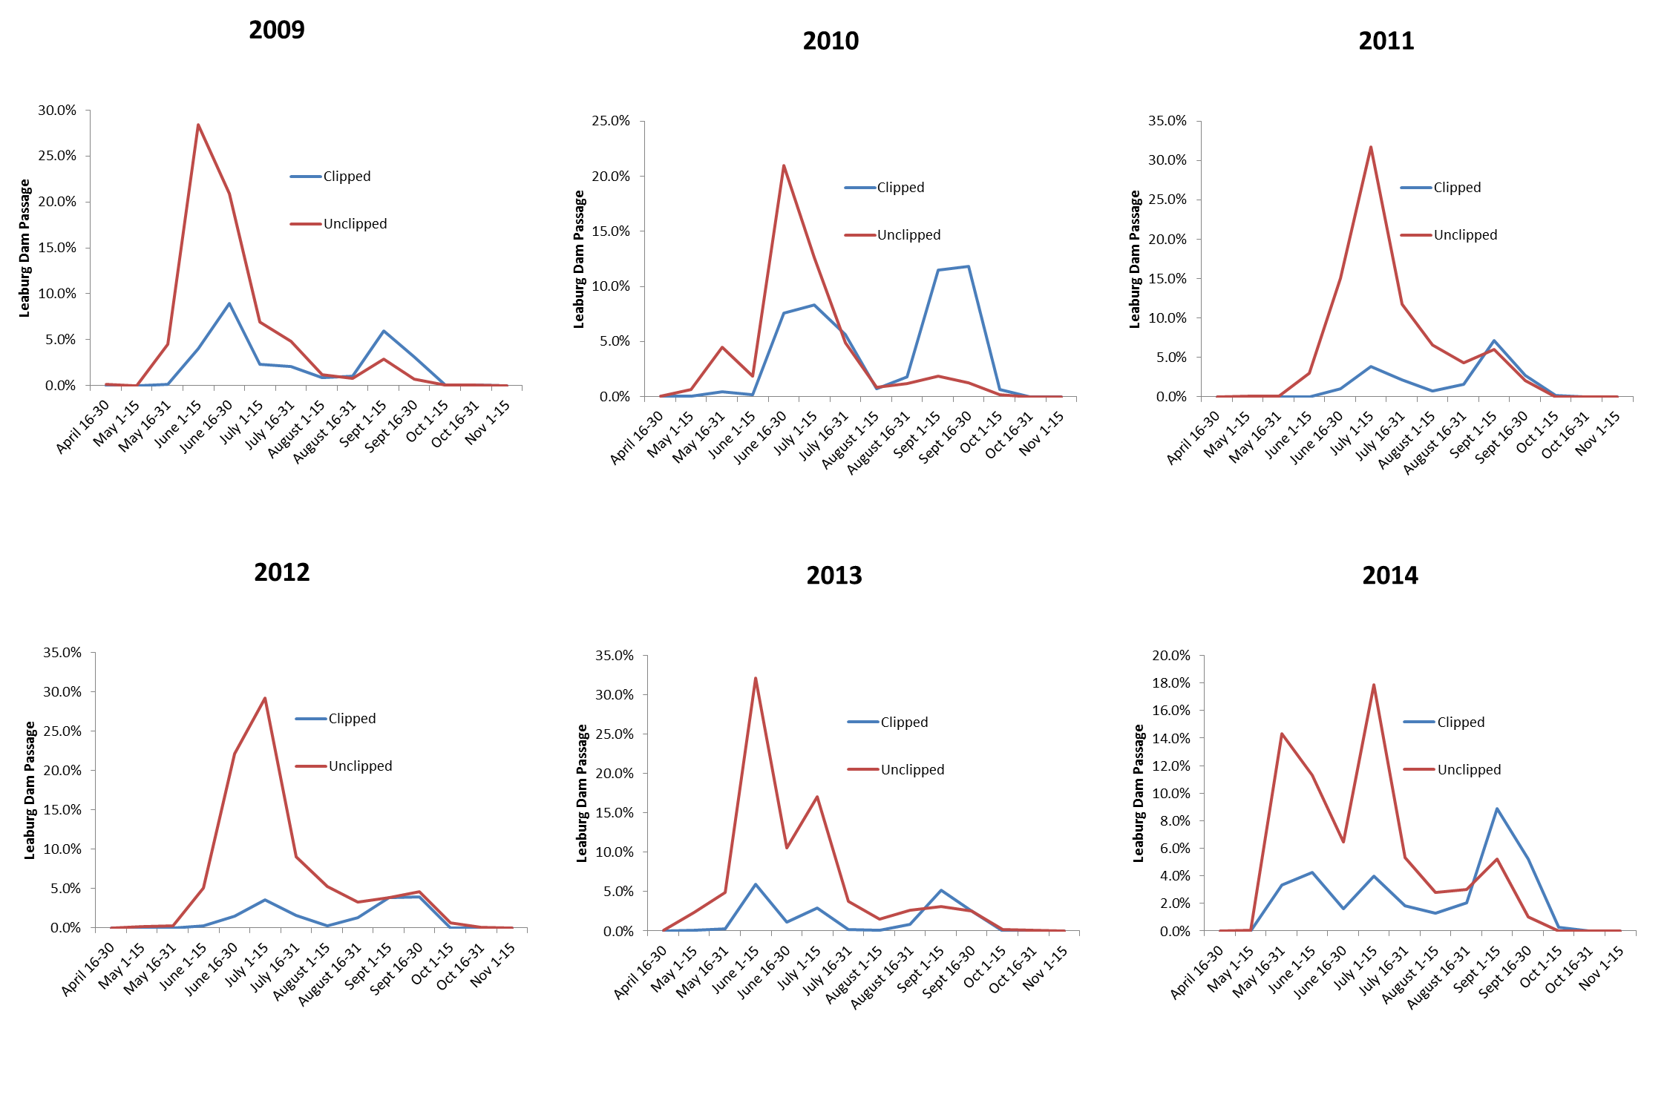

**Figure 2. Average percent passage (cumulative) of clipped and unclipped Chinook salmon by two-week interval at Leaburg Dam: 2009 – 2014.**

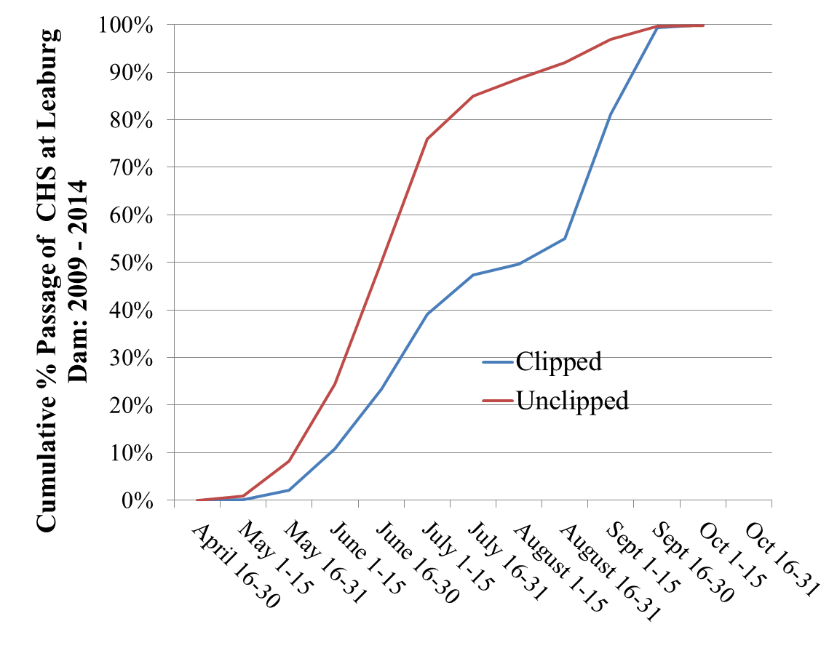

Table 1. Draft schedule for Leaburg Dam trapping operation for Chinook salmon (ChS) in 2015. Ad and NM indicate adipose clipped and non-marked fish. Draft schedule assumes that NM ChS counts drop precipitously in the third week of July. Schedule will shift if that event occurs earlier or later.

|  |  |  |  |
| --- | --- | --- | --- |
| Dates | | | Action |
| 1-Jul | - | 10-Jul | Monitor relative abundance of Ad and NM Chinook |
| 13-Jul | - | 17-Jul | Install trap. AM and PM trap checks. Trap and transport Ad ChS to McKenzie Hatchery |
| 20-Jul | - | 2-Oct | Continue trapping. AM and PM trap checks. Trap and transport Ad ChS to McKenzie Hatchery |